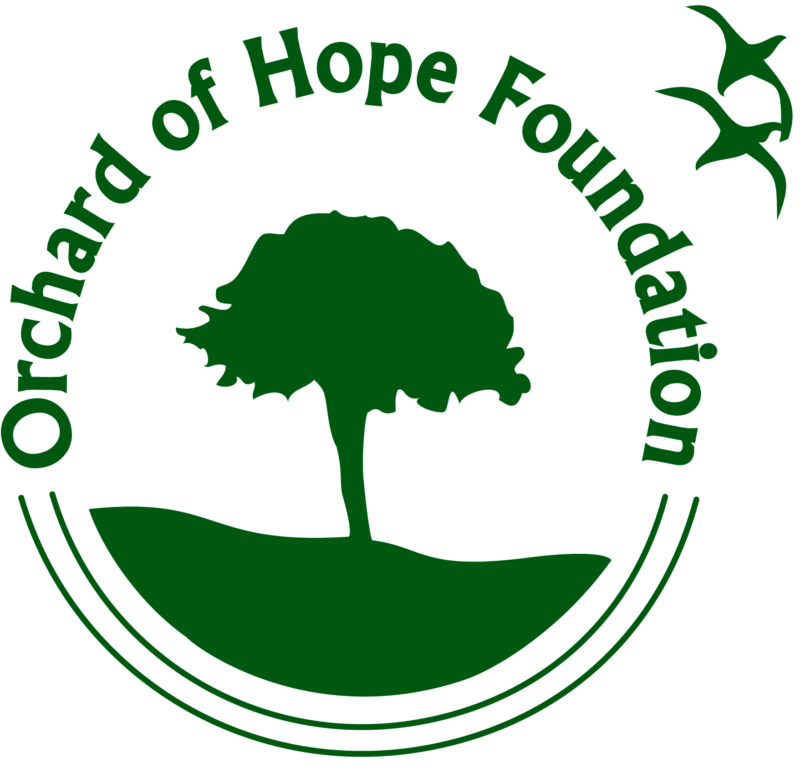
17TH ANNUAL WALK FOR HOPE
Don't miss out on a great opportunity to become a sponsor for the ORCHARD OF HOPE FOUNDATIONS'S WALK FOR HOPE to be held on July 15, 2017. Your sponsorship will help the Foundation towards their mission of providing financial support for cancer patients and their families in Fremont County.
Teams will gather in Veteran's Park on the 15th of July to fundraise and compete for the traveling trophy. Friends, family, co-workers and the public are all welcome to attend this event. This year's focus will be celebrating the cancer champions of our community and we look forward to a fun day. Food and music will be available all day. Team members will compete in games for a trophy. All registered CANCER CHAMPIONS receive a t shirt and medallion.
We will be selling balloons until 1:00 p.m. the day of the event to honor our cancer champions and to remember our lost loved ones. As part of our closing ceremonies the balloons will be released and the names read.
As in the past, our success depends largely on the contributions from the sponsors in our community. Attached is a sponsorship form allowing you to choose your level of participation. Also attached is a balloon form and an "INTERESTING FACTS" sheet detailing our mission. We would encourage you to put a team together and come and see how much fun we have. Donations of items to be used for drawings throughout the day are also welcome.
A Team Captain's meeting will be held on Monday, APRIL 24, 2017, at 6:00 P.M. at Shepherd of the Hills Lutheran Church at 801 Sheridan in Canon City. Call Michaelene Jacobs at 429-4274 or the Orchard of Hope office at 275-0089 for more information. The office is open from 10 a.m. to 3 p.m. on Monday, Tuesday and Friday.
Check out our web site at www.orchardofhope.org or e mail us at fremont@orchardofhope.org. Like us on Face Book to keep up to date on all of our events.

